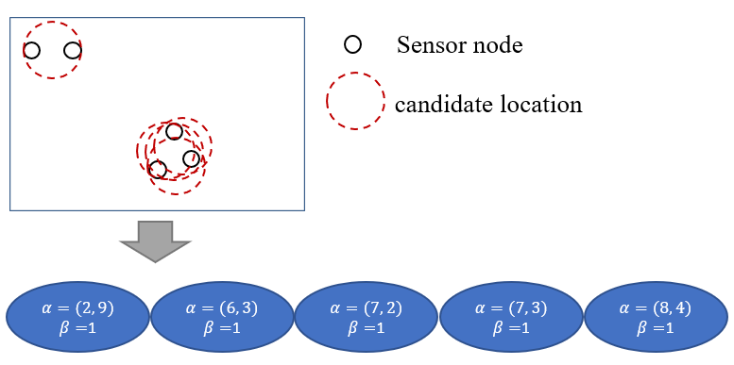

Figure 5. Example of a chromosome coding